Bash script tasks
If else statements
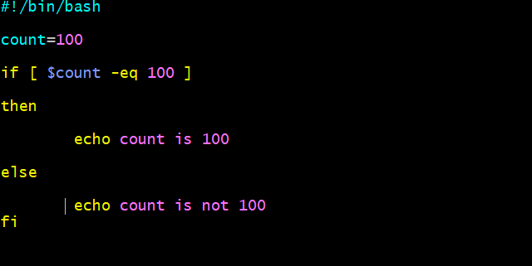
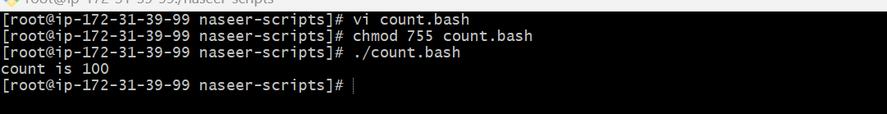
Case statement scripts
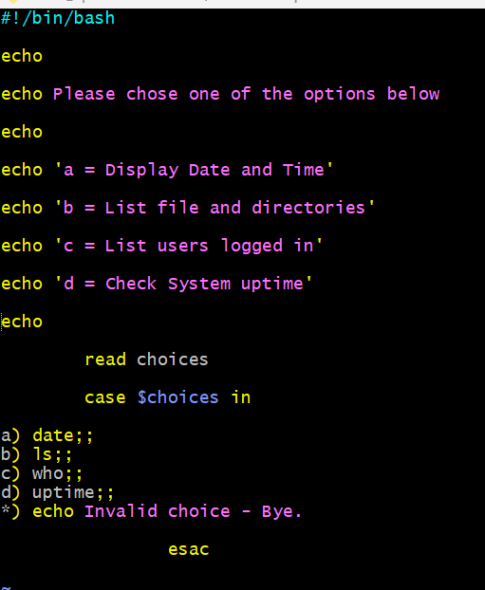
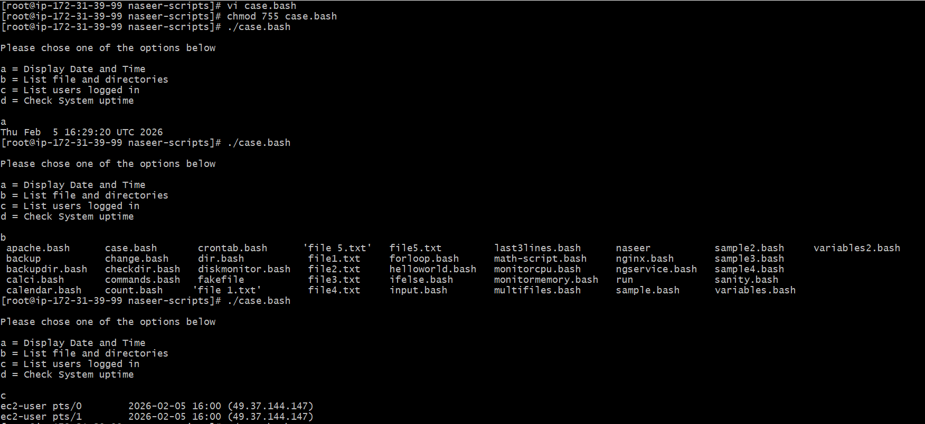
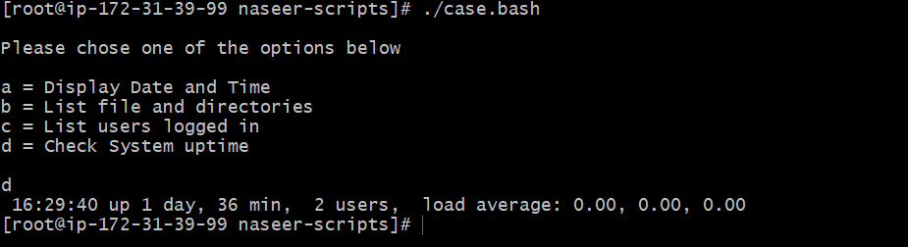
Do while scripts
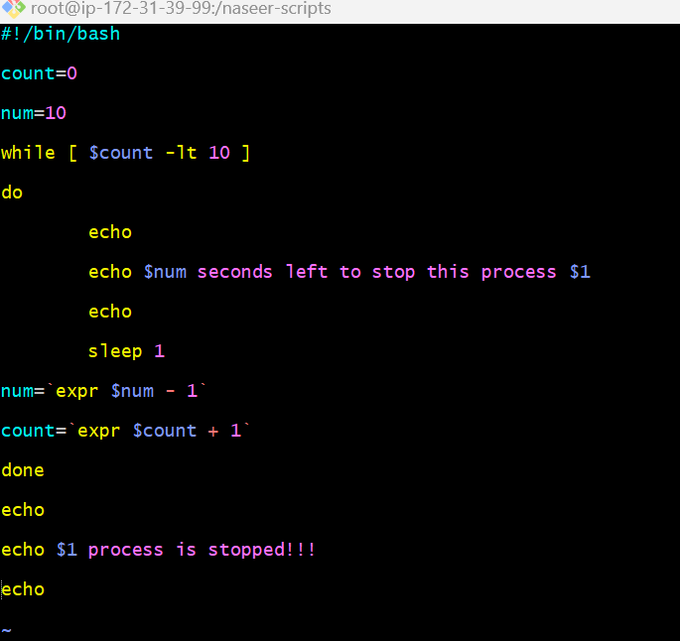
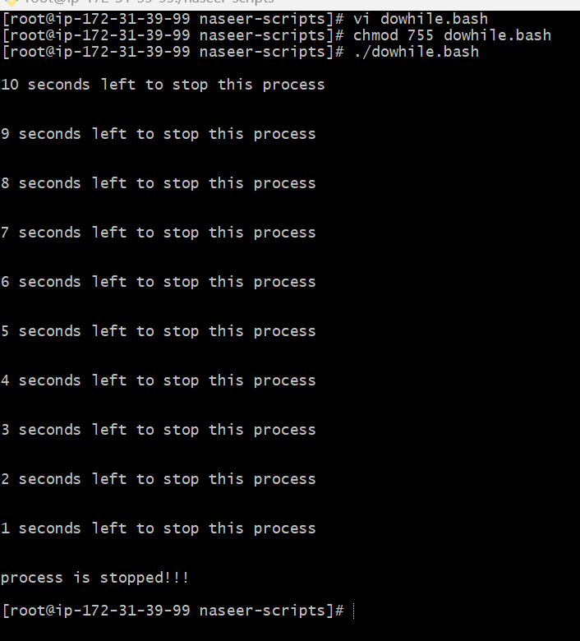
Create a bash script to check if a directory is available or not.
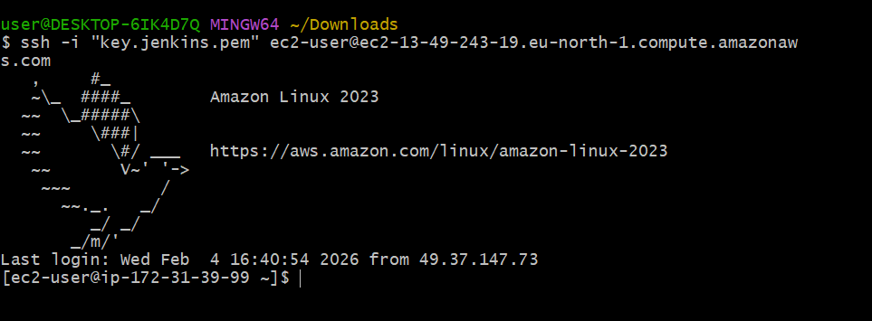
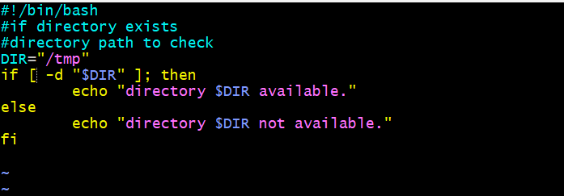

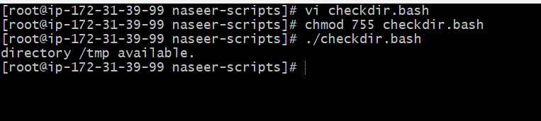
Create a bash script to create multiple files.
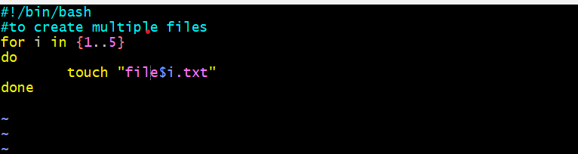
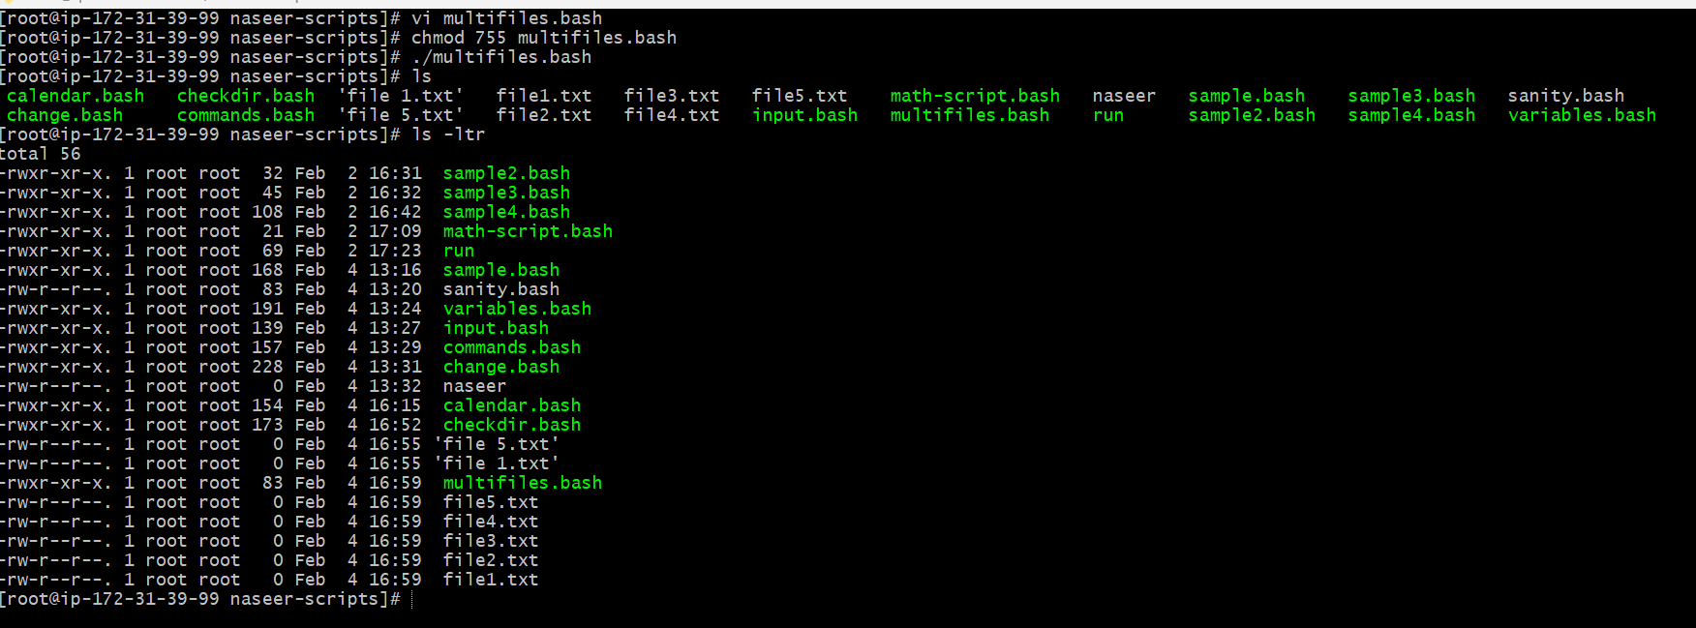

Create a bash script to take a backup of a directory.
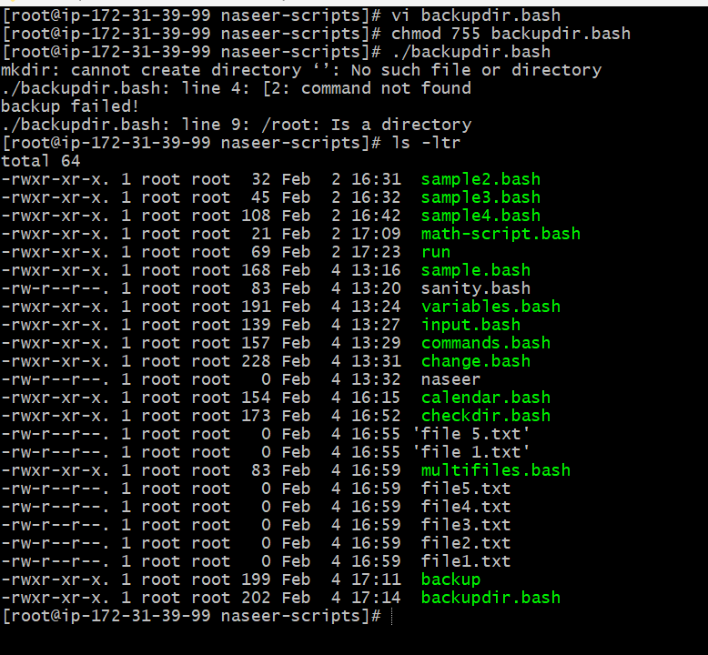
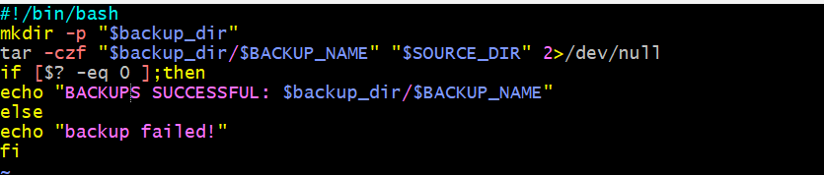

Create a bash script to install Nginx on an EC2 server.
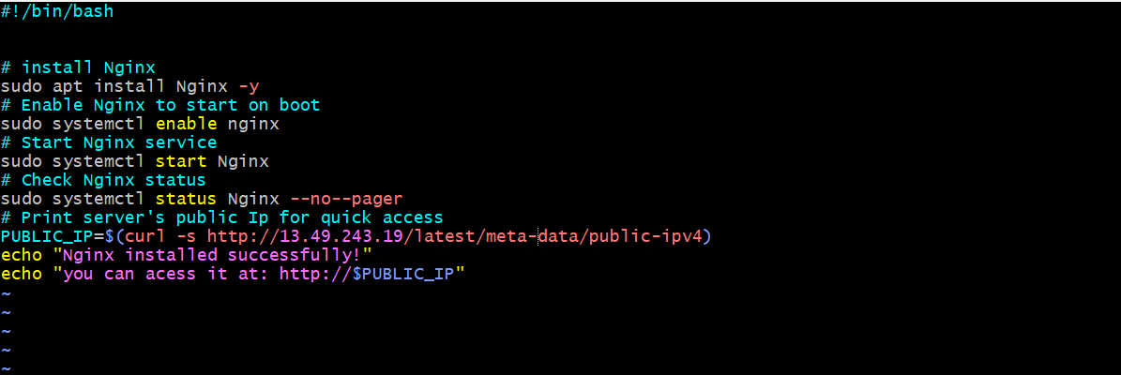
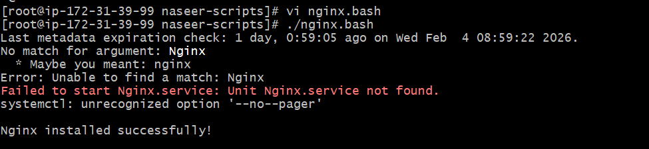
Create a bash script to install Apache Tomcat on an EC2 server.
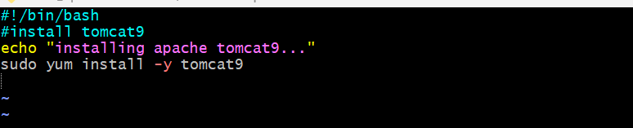
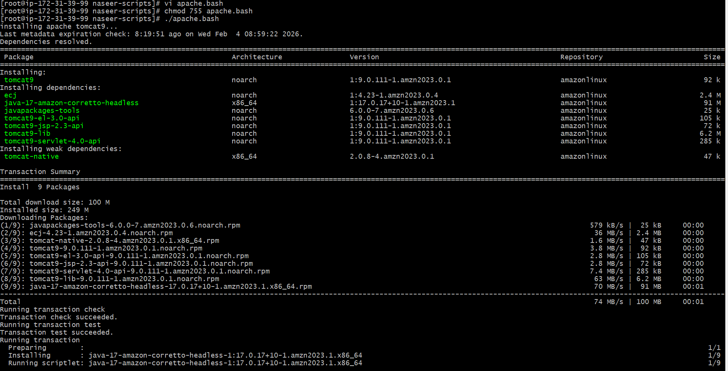
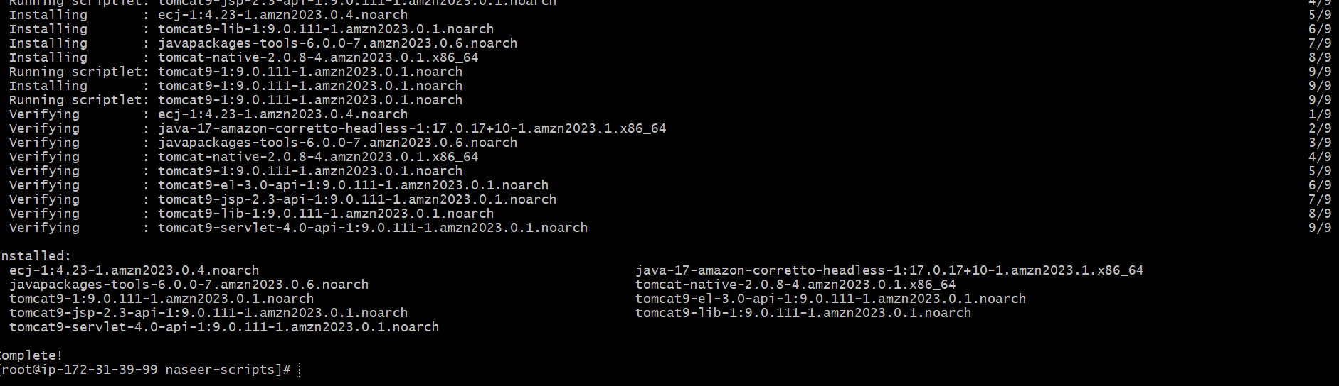
Create a bash script to check if the Nginx service is running, if not running then script should start the service.
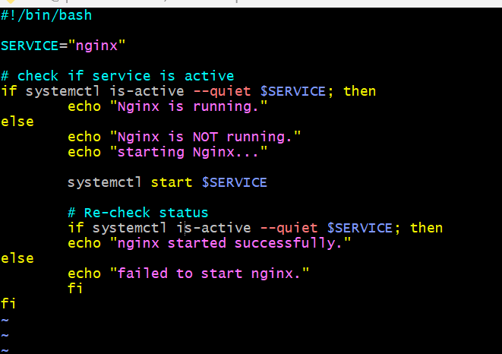
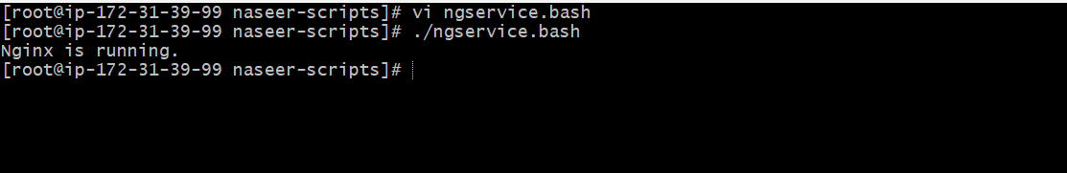

Create a bash script for a calculator.
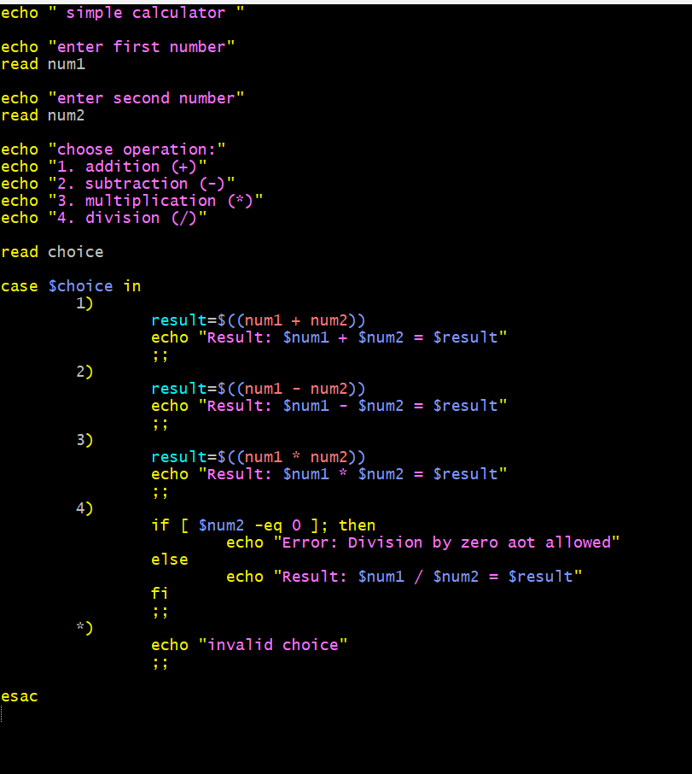
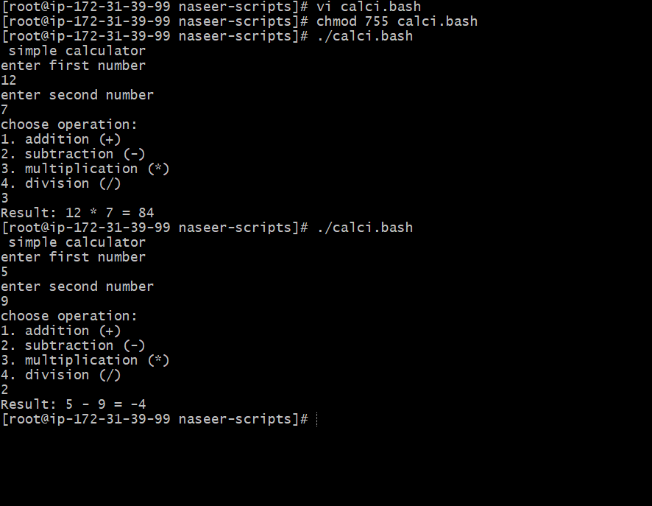

Create a bash script to check if a directory exists, if not then create a directory.
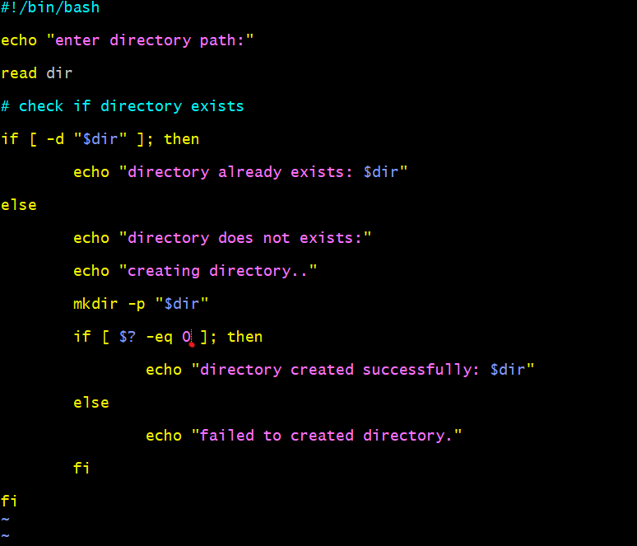
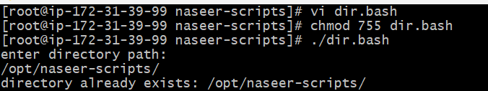
- Create a bash script to delete the last 3 lines of a file.
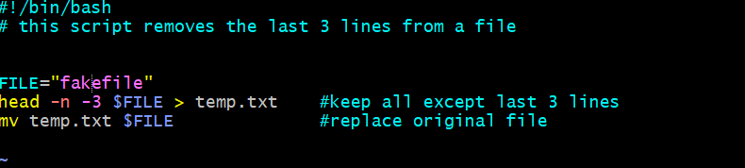
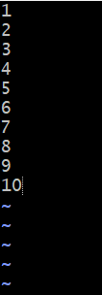
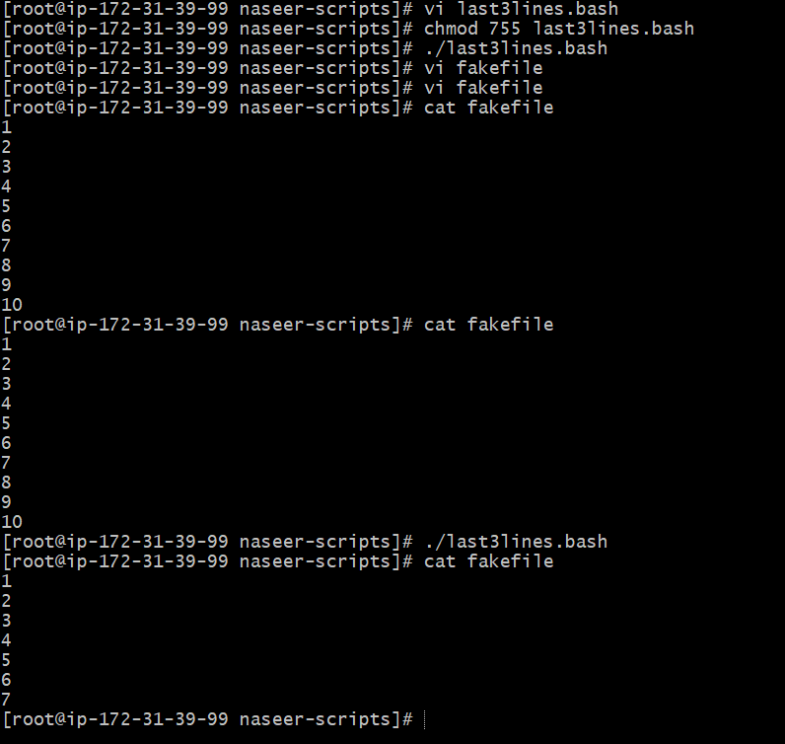

- Bash script to monitor cpu and if it is more than 80% then send email notification.
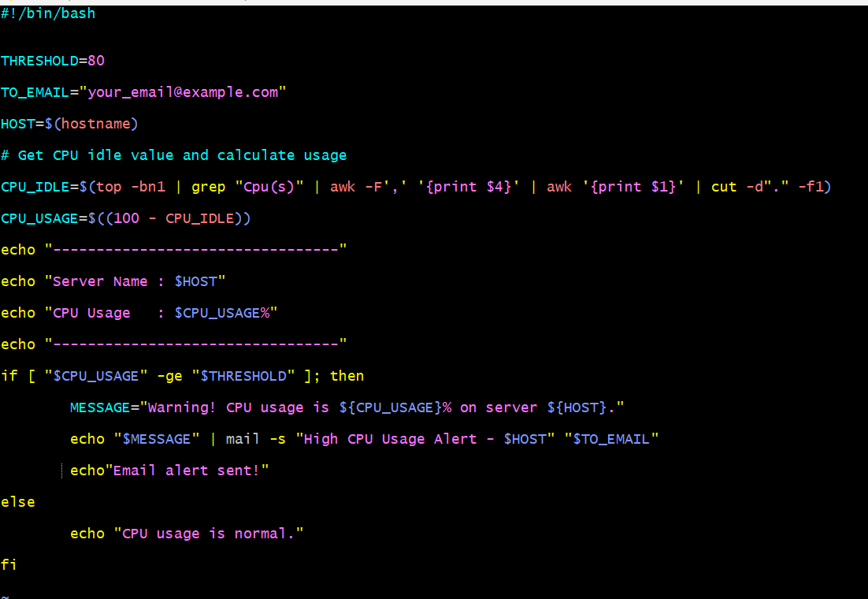
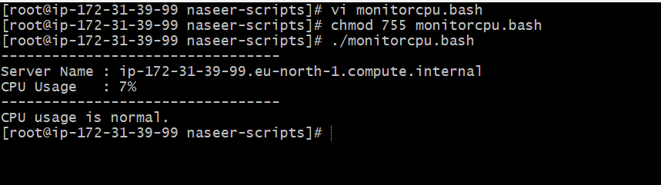

- Bash script to monitor disk space and if it is more than 80% then send email
notification.
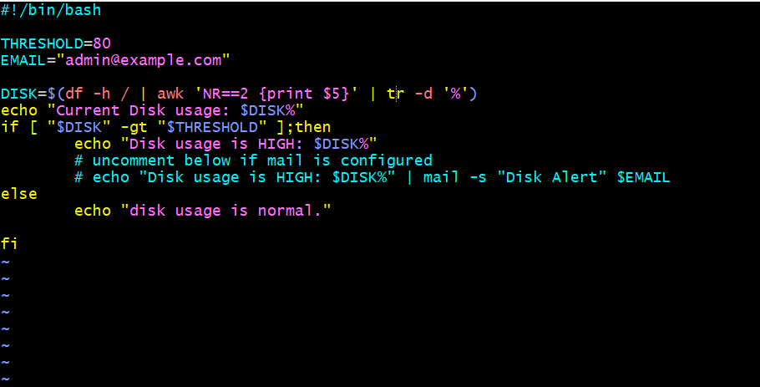
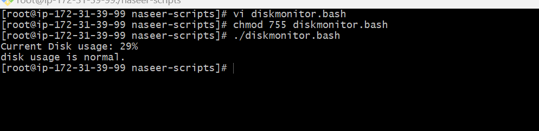

- Bash script to monitor memory and if it is more than 80% then send email notification.
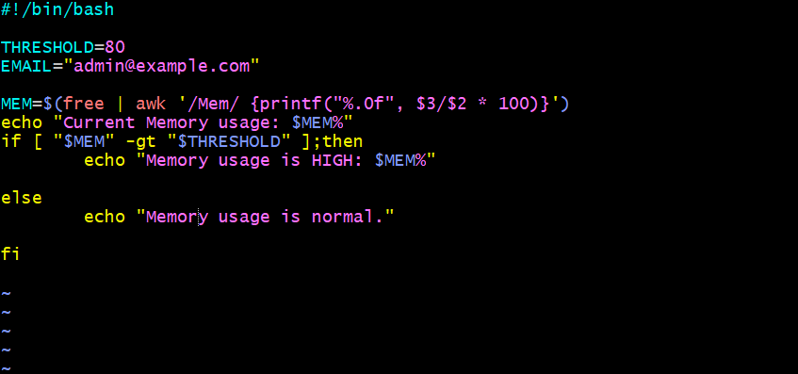
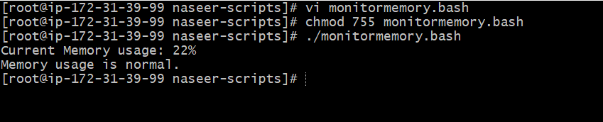
Exercise: Crontab Entries
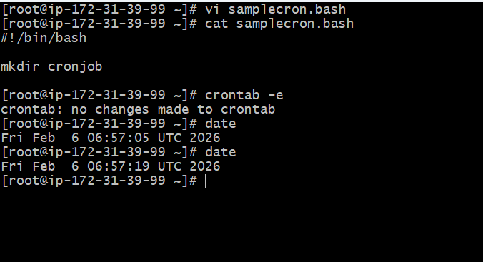
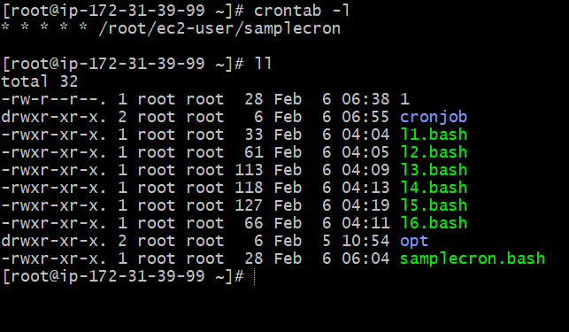
1. April 5th Midnight
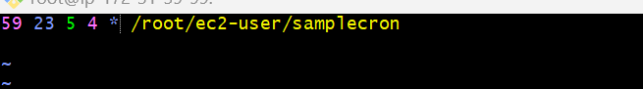

2. 5th of Every November, January, June if it is a Thursday


3. At 05 and 27th minutes of 9, 10, 11 hours every day
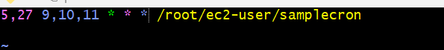
- 34 minutes of 9th hour on 15th August
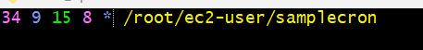

5. Every midnight

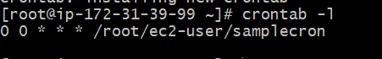
6.Every Weekend (Saturday night 11:59 PM)
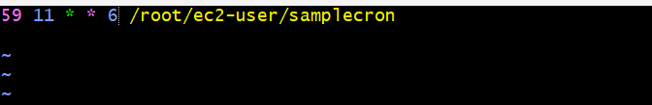
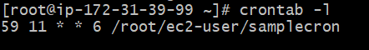
7. After every reboot
